Step 4: ContainerizationContainerize the API.

* Ensure the Spring Boot application is built as a JAR file

Open a terminal in the project root directory

Run the following maven command to build the project (maven version 3.9.2 + JDK 17)

mvn clean package

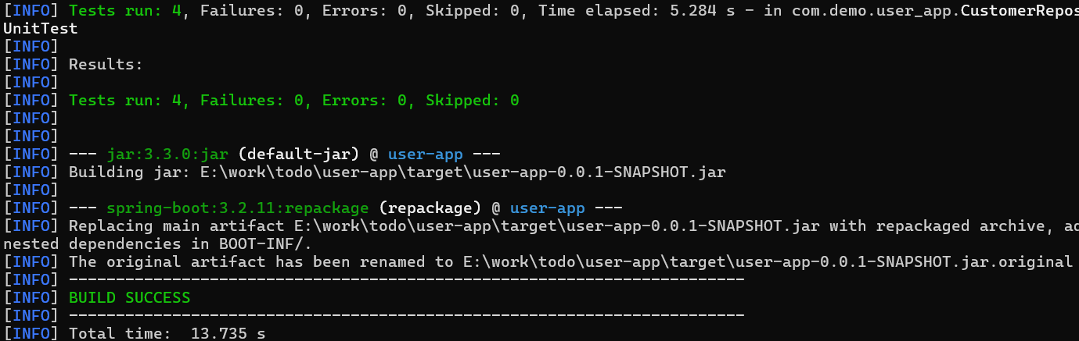

If you see the BUILD SUCCESS message, then the user-app-0.0.1-SNAPSHOT.jar is available.

* Build the Docker image with the Dockerfile

There is a Dockerfile in the project root directory and we can run the following command to build the Docker image:

docker build -t cust-api

* Run the Docker container and test the API

Once the image is built, we can run the container with the following command:

docker run –p 8080:8080 cust-api

If the container is running, we can access the API via <http://localhost:8080/api/customer> and the Swagger UI should be accessible via <http://localhost:8080/swagger-ui/index.html>

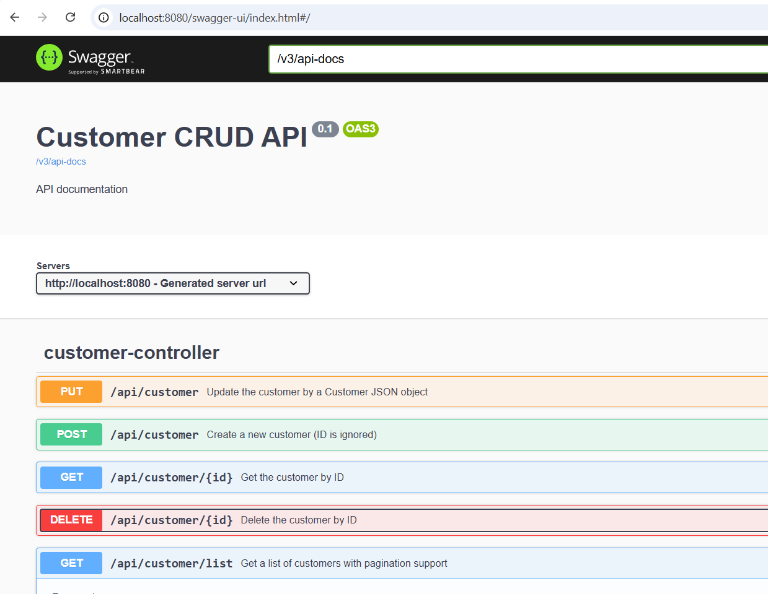

* Preloaded testing data

As we mentioned in document “Step 2 Integration Testing”, the H2 database contains a created table CUSTOMER and you can open the H2 to check the table and try with the Swagger UI. Try the following H2 console link http://{your-service-ip}:{port}/h2-console/ console (no password needed) and make sure the JDBC URL is jdbc:h2:mem:testdb

